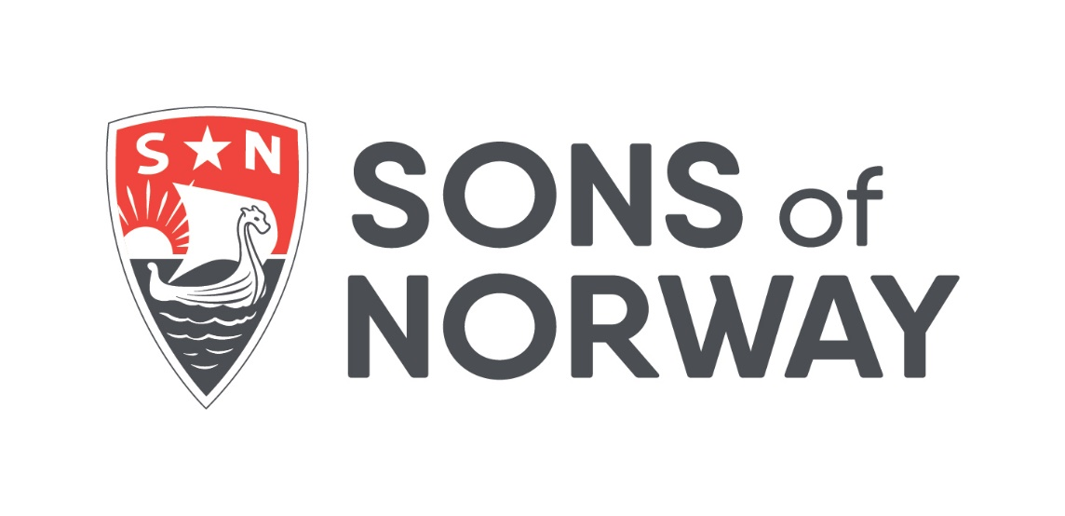

**International Board**

**Application Agreement**

**August 2023**

**Preface**

This document has been prepared to give prospective international and alternate international director candidates a good idea of what will be expected if elected to one of those positions. While the job requires a lot from each board member, with dedication and effort positive results can be obtained by most experienced Sons of Norway (SON) members. If, after reading this, there are further questions, do not hesitate to contact any member of the International Board of Directors (IBOD) for further clarification.

**Introduction**

Every corporation, and SON in particular, has a two-tiered management structure.

The IBOD is the supreme governing body of SON, while the president & chief executive officer (CEO) is the primary force managing the day-to-day operations on behalf of the benefit members and the IBOD.

Corporate governance is defined as the processes, structures, and relationships through which the IBOD develops policies and oversees what its executives do.

Corporate management, i.e., the CEO, is responsible for implementing the board’s policies and for making all the resources of the corporation fully productive.

Corporate governance, i.e., the board, is every bit as important as corporate management to ensure the growth and progress of the company. Often when you find a business in trouble you will find a board of directors either unwilling or unable to fulfill its responsibilities.

A strong board spurs management to be more professional and an optimal relationship between board and management creates an exciting and favorable dynamic. For the organization to function effectively, an atmosphere of trust between the board of directors, management, and members is essential.

Each of the governing partners, that is, the board of directors and corporate management, needs to be strong and independent, yet cognizant of their common goal – the success of the organization. This merely recognizes as basic truth that management inevitably views the role and meetings of the board of directors differently than does the board itself. It is the international board chair’s job to see that the board, on behalf of the benefit members, gets what is wanted and needed for the success of the organization and this cannot be done without the support of the CEO.

The principal concerns of the board include monitoring the broad policies of the society, its general direction, pace, priorities, and ensuring that the board decisions are carried out.

The board should not become involved in the details of the day-to-day business operations. However, the board should be fully informed in advance of all major proposals and should have adequate opportunity to make a meaningful and deliberate contribution to the decision-making process.

What, then, are the primary responsibilities of the board of directors? What is the basis of corporate governance to its philosophy and structure? The board’s role is not to just give rubber stamp approval to what management does, or to be available in case of an emergency or crisis.

The board’s role can be defined as follows:

1. The board is the supreme governing body of Sons of Norway.
2. The board is accountable to certificate holders, members, regulators, auditors, other board members, and the general public as a fiduciary of a tax-exempt entity.
3. It is independent of management.
4. The philosophy of operations of the board and its committees must be designed to make the board independent and responsible.
5. It must ensure the organization is soundly managed and oversees its operations.
6. It is responsible for ensuring that management succession is thoroughly planned.
7. It establishes policies for carrying out the business of the society.
8. The board has the vital role of protecting the society’s future. The board must see that management always has that approach.
9. It must ensure a future-oriented culture within the corporation.
10. One of the board’s most important functions is to approve, or send back for amendment, management recommendations relating to the future direction of the corporation.
11. The board must play a positive role in examining the objectives and the progress of the society in achieving what it hopes to be.
12. To fulfill its governance role, the board needs an informed and independent view of the society – its strengths and weaknesses, its management, and its prospects.
13. An informed international board chair assures the board will not be dependent solely on management’s view.

Adherence to the principles outlined above, and recognition by both partners that one cannot function without the other, will strengthen the society and ensure its success.

**Legal Duties**

There are broad legal duties imposed on officers and directors under state and federal law. These are the duty of care, the duty of loyalty, and the duty of obedience. In general, board members are required to spend sufficient time with the business of the society to comply with their fiduciary duty of care and loyally serve the society’s best interests.

**Duty of Care**

The duty of care is a legal obligation imposed on a board member by law. That obligation is to hold a requisite level of competence and care toward the organization. The duty of care describes the level of competence that is expected of a board member and is commonly expressed as the duty of care “that an ordinarily prudent person would exercise in a like position and under similar circumstances.” This means that a board member owes the duty to exercise reasonable care when he or she makes a decision as a steward of the organization.

**Unique Duty of Care**

To act in good faith, a board member must act in the best interests of the organization as a whole, not in self-interest, the interests of others, or the interests of their district/local lodge. While a board member may be labeled as an international director or officer from a particular district, he/she was elected by the benefit members to serve the interests of all members. This is a heightened standard. Board members are fraternal leaders AND corporate board members. While an IBOD member, all service must be conducted under this unique standard.

**Confidentiality**

Confidentiality is an important part of the duty of care. Board members are stewards of information. Each board member is required (by state and federal law) to safeguard information received electronically, verbally, and in hard copy form. Information may not be disclosed to anyone (other than officers, directors, employees, or authorized agents) that is not already known by the general public or is part of the public record. This ensures candor and open communication among board members.

**Duty of Loyalty**

Board members owe a duty of undivided and unqualified loyalty to the organization.The duty of loyalty is a standard of faithfulness; a board member must give undivided allegiance when making decisions affecting the organization. This means that a board member can never use information obtained as a board member for personal gain or the gain of others but must act in the best interests of the organization. This duty precludes a board member from exercising their authority in their own interest or in the interest of another.

Board members are precluded from engaging in outside activities that may adversely impact SON. In other words, board members shall not authorize or engage in transactions except those in which the best possible outcomes or terms for the organization can be achieved. This standard constrains a board member from participating in board discussions and decisions when they, as an individual, have a conflict of interest (i.e., their personal interests conflict with organizational interests, they fail to disclose prior involvement or unique knowledge related to a decision before the board, or they serve multiple organizations whose interests conflict).

**Duty of Obedience**

Obedience to the organization’s mission, bylaws, and policies, as well as honoring the terms and conditions of other standards of appropriate behavior such as laws, rules, and regulations is required. A basis for this rule lies in the public’s trust that the organization will manage the tax-advantaged assets to fulfill the organization’s mission. In essence, board members must ensure that the organization complies with all applicable federal, state, and local laws and regulations, and that it remains committed to its established mission.

**Code of Ethics and Conflict of Interest Policy**

SON and the Sons of Norway Foundation are required to implement and properly administer a code of ethics and conflict of interest policy which sets forth standards of conduct for board members, district presidents, staff, insurance professionals, key consultants, and others that may be required to comply therein.

**Conflicts of Interest**

A conflict of interest is a set of circumstances that creates a risk that professional judgment or actions regarding a primary interest will be unduly influenced by a secondary interest. A board member shall avoid such conflicts, and the appearance of such conflicts, at all times. Accordingly, it is improper for a board member to put him or herself in a position where personal interests (or the interests of another) are in conflict with SON. Personal opinions, financial and fiduciary interests, outside activities, etc. all have the potential to create real or perceived conflicts of interest. Conflicts may be personal or financial in nature. A conflict of commitment may arise when a board member is too busy with outside activities or responsibilities to lend the required time, energy, creativity, or personal resources to the position.

Examples of conflicts:

* Using the position for improper influence or gain
* Personal agendas or opinions which cloud or alter decisions in the best interest of the organization
* Being a party to a prior action or dispute that is now referred to the board for adjudication
* A board member’s outside interests that may cause harm to SON’s business interests or reputation
* Associating with an entity in direct competition with SON

**Conflict Disclosures**

SON’s conflict disclosure policy and compliance procedures require that a conflict be disclosed at its inception – not just annually on the disclosure form.

**Employee Handbook**

SON employees are bound by an employee handbook. Board members are encouraged to review the handbook and must adhere to certain policies, such as the sexual harassment policy, while working with staff.

**Legal Protections Afforded Board Members**

* The **business judgment rule** is a legal theory adopted by statute which provides protection for board members who are informed, act in good faith, and with due care. They must act in the best interests of the organization without self-interest. It protects against honest mistakes and errors. Two requirements: 1) must act, 2) with due care.
* **Non-management director theory** The law allows for the permissible reliance on others (such as management) as long as the board member was supervising and did not have knowledge of the mistake or error.
* **Indemnification** The SON bylaws provide indemnification to the board and those working with the board to obtain reimbursement for claims, legal expenses, and other costs arising out of service to the organization.
* **Insurance** SONhas director and officer liability insurance coverage. Intentional misconduct and criminal acts are excluded from this coverage.

**Beyond Legal Obligations**

The roles and responsibilities of board members are more extensive than mere legal compliance. Every board should develop its own set of member expectations that address the needs and interests of the organization at that time. Furthermore, the status of expectations should be an annual agenda item to determine the ongoing needs of the organization.

**Expectations of Board Members**

* Participate actively
* Be knowledgeable and make informed decisions
* Speak in one voice and serve as an ambassador of the board
* Remember who elected you – the benefit members
* Serve with honor, integrity, and candor
* Work effectively as a team
* Advise wisely based on having the requisite knowledge gained from doing homework on issues facing the board
* Must serve on a board committee(s)

**Proper Role of the Board of Directors**

* **Strategic** Partner with management to develop overall strategic direction for the organization (*leadership*).
* **Fiduciary** High level oversight of the use of organizational assets (*stewardship*).

**Strategic Duties**

A board member’s strategic duties involve partnering with management to develop strategies for the success of the organization. The level of contribution directors can make to this process will depend on experience, knowledge, and skills in relevant areas. Even where strategic plans are driven primarily by the CEO, the board should act as a sounding board and reviewer. The board ultimately determines where the organization will go, not necessarily the specifics on how it will get there. The board provides support for the allocation of organizational resources toward achievement of goals and objectives. This process involves partnership and leadership.

Strategic duties include:

* Development of overall fraternal mission and values
* Development of long-term strategic plan
* Development of long-term objectives, goals, and measures
* Development of short-term objectives, goals, and measures
* Review and approval of budgets
* Determine CEO’s compensation and structure

**Fiduciary Duties**

A board member’s fiduciary duties require a high level of oversight and stewardship. Those duties include, but are not limited to, oversight and stewardship of the following:

* The organization’s assets
* The strategic vision and goals
* Fraternal operations and the lodge system
* Fraternal programs and membership
* Adherence to the organizational bylaws and policies under which SON operates
* The furtherance of the charitable purpose

**Specific Duties for Management of the CEO**

This is the only area where the board acts as a manager. It is not to be confused with day-to-day supervision. The board needs to trust the CEO to do his/her job; the board makes a terrible CEO. A board sets parameters through budget, strategic plans, goals, and measures.

The board should conduct an evaluation of the CEO's performance at least annually in light of established goals and objectives and provide feedback.

**Specific Duties for the Oversight of Results**

The board must:

* Review and fully understand financial statements and their meaning
* Engage an independent auditor to ensure that statements are accurate and complete
* Evaluate progress toward the attainment of established goals and objectives
* Evaluate investment performance in light of pre-determined measures and benchmarks

**Specific Duties for the Management of Risk**

The board must ensure that adequate processes are in place to manage risk – not to directly audit. The board works with management to ensure adequate processes are in place for:

* Ensuring regulatory compliance
* Managing conflicts of interest
* Business continuity
* Accountability and oversight of SON’s fraternal and business operations
* Management of investment risk

In addition, the board works with SON’s independent auditors to ensure adequate processes are in place for managing financial risk.

All board members have a duty to be well informed regarding SON business. A major responsibility of all board members is to read and be prepared to discuss all issues that may come before the board. Preparation for board meetings, including reading all minutes, reports, and other communications is a necessity.

A director is expected to attend all directors' meetings and to have a general knowledge of the financial condition of the society and its system of management. A director is expected to ask for and read the corporation’s annual financial statements.

A board member can expect to spend a minimum of 10-20 hours a week on board-related activities.

All board members will be appointed to working committees. These committees will convene during board meeting weeks but will likely involve time for further preparation and production at home.

**Guidelines for International Officers and Directors**

1. The primary responsibility of the members of theIBODis to establish policy and procedure and, in general, to determine directives for management as outlined in the *Charter, Bylaws, Policies & Procedures (CBPP).*
2. Theinternational director shall participate in the institutional meeting of a new lodge, upon notification of the district president or secretary.
3. The international director(s) and international officer(s) may install the officers of an established lodge, if requested.
4. The international director(s) may accept a special invitation from a lodge within another district upon notice to the international director(s) of such other district and approval of the international board chair.
5. The international director(s) is (are) not a member of his/her respective district board by virtue of being a member of the IBOD.
6. Members of the IBOD are encouraged to refrain from running for district office while they are international directors but should work closely with district officers and boards in promoting district and international operations and activities for the good of the order.
7. Members of the IBOD shall not endorse a candidate for employment at SON.
8. Members of the IBOD shall not endorse or allow their name to be used for the purpose of promoting a good or service for commercial reasons.
9. As the majority of board communication is via email or only accessible by computer, each IBOD member must possess the requisite computer skills and technical competence with which to participate in those communications.

**Governance Regulation**

SON leaders have become familiar with the *Corporate Governance Model Act and Annual Disclosure (CGAD).* The law requires SON to file a lengthy disclosure form detailing the governance structure of the organization and relationship between the IBOD and SON management.

Many governance changes have been implemented over the past several years and many more will be contemplated in the coming years. Every June, SON must report to insurance regulators on the status of its governance.

Some of these disclosures include:

* Duties of the board and each of its significant committees and how they are governed
* The number of meetings held by the board and its significant committees over the past year and information on director’s attendance
* The rationale for the current board size and structure
* How the qualifications, expertise, and experience of each board member meet the needs of the insurer
* How the insurer identifies, nominates, and elects members to the board and its committees
* A description of the nomination committee in place to identify and select individuals for consideration
* How the election and re-election processes function

IBOD members must take a keen interest in good corporate governance and related compliance as the board completes this annual governance disclosure and board members may be asked to respond to its contents.

**Please review and complete the next page. Scan and send via email or send by post to the chair of the international nominating committee.**

**Acknowledgement**

Candidate’s Name: ____________________________________________________

District/Local Lodge Name and Number: ____________________________________

Candidate for:

🞏 International Director

🞏 Alternate International Director

I certify that I have read the above and understand the obligations and requirements of the job of international officer or director of Sons of Norway and that I am both willing and able to dedicate the time and energy necessary to meet those obligations and requirements.

__________________________________________ __________________

Signature Date

__________________________________________

Printed Name

____________________

Member Number

**Scan and send via email or send by post to the chair of the international nominating committee.**